EXPT NO: 8 | TRAIN A SIMPLE AUTOENCODER FOR DIMENSIONALITY REDUCTION AND FEATURE LEARNING
DATE: 02.11.2026

PRE-LAB QUESTIONS (PROVIDE BRIEF ANSWERS TO THE FOLLOWING QUESTIONS)

- What is an autoencoder?
Ans: An autoencoder is an unsupervised neural network that learns to copy its input to its output through a narrow middle layer. It first compresses the input into a small code and then reconstructs the original input from that code, so it learns the most important features of the data without needing labels.
- What are the roles of the encoder and decoder in an autoencoder?
Ans: Encoder: takes the input (for example a 784-pixel image) and maps it step by step to a smaller latent vector (for example 32 values).
Decoder: takes the latent vector and maps it back to the original input size, trying to rebuild the original data as closely as possible.
- What is dimensionality reduction?
Ans: Dimensionality reduction means representing data with fewer features (dimensions) while keeping as much useful information as possible, e.g. reducing a 784-feature image to 32 features. It lowers storage and computation, removes noise and redundancy, and makes data easier to visualize. PCA and autoencoders are common methods.
- What is meant by latent representation or latent space?
Ans: The latent representation is the compressed code produced by the encoder at the bottleneck layer. It holds the learned, most informative features of the input in a hidden (not directly observed) form. The space of all such vectors is the latent space, where similar inputs lie close to each other.
- Why is reconstruction loss used when training an autoencoder?
Ans: The target of an autoencoder is its own input, so training needs a measure of how different the reconstructed output is from the original. Reconstruction loss (mean squared error or binary cross-entropy) gives this measure; minimizing it forces the bottleneck to keep the information needed to rebuild the input, and no labels are required.
AIM
To implement and train a simple autoencoder using a dataset such as MNIST, learn a lower-dimensional representation of the input data, and evaluate the model by reconstructing the input samples and visualizing their latent representations.

SOFTWARE REQUIREMENTS
- Python
- TensorFlow / Keras
- Google Colab or Jupyter Notebook
- GitHub
- NumPy
- Matplotlib
- Pandas (optional)

OBJECTIVES
Students will be able to:
- Understand the architecture and working of autoencoders.
- Differentiate between the encoder, latent representation, and decoder.
- Prepare and preprocess a dataset for autoencoder training.
- Build an autoencoder using appropriate neural network layers.
- Train the model using reconstruction loss.
- Perform dimensionality reduction and extract latent features.
- Visualize original and reconstructed samples.
- Evaluate reconstruction performance using loss values and visual inspection.

PROCEDURE
PART A: DATASET PREPARATION AND PREPROCESSING
Perform the following tasks:
- Load the MNIST handwritten digit dataset using TensorFlow/Keras.
- Explore the dataset and check the number of training and testing images and their dimensions.
- Display sample images from the dataset.
- Convert pixel values to floating-point values and normalize them to the range [0, 1].
- Flatten each 28 × 28 image into a 784-dimensional input vector for a basic dense autoencoder.
- Prepare training and testing data. Use the input images as both input and target output because the autoencoder learns to reconstruct its input.

CODE AND OUTPUT :

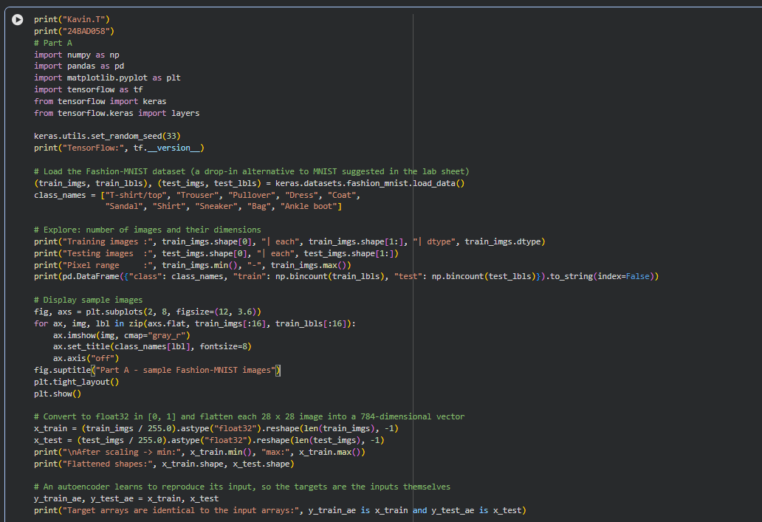

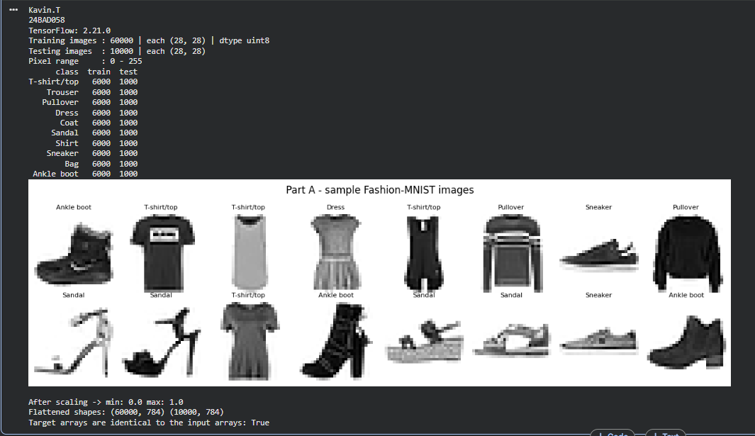

PART B: IMPLEMENTING THE ENCODER AND DECODER
Perform the following tasks:
- Define the input layer with 784 features.
- Build the encoder using one or more Dense layers to map the input to a smaller latent dimension, such as 32 features.
- Build the decoder using Dense layers to map the latent representation back to 784 output values.
- Use suitable activation functions, such as ReLU for hidden layers and Sigmoid for the final layer.
- Combine the encoder and decoder into a single autoencoder model.
- Display the encoder, decoder, and autoencoder model summaries.

CODE AND OUTPUT :
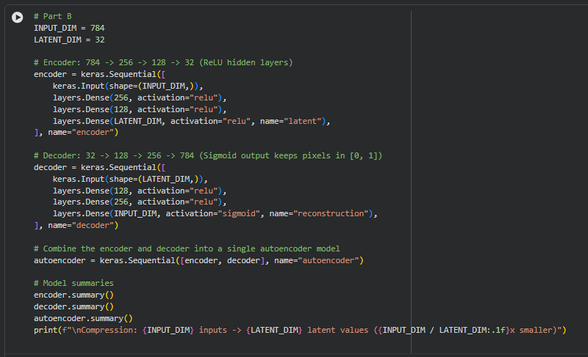

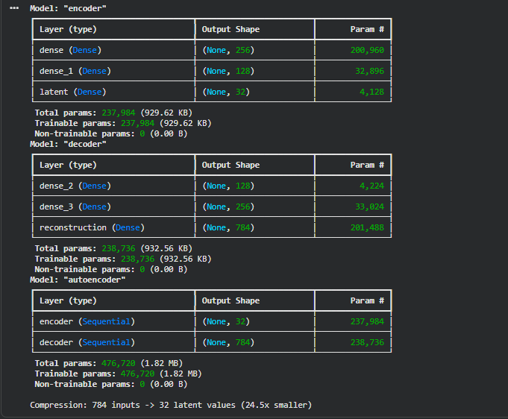

PART C: COMPILING AND TRAINING THE AUTOENCODER
Perform the following tasks:
- Compile the autoencoder using an optimizer such as Adam.
- Select an appropriate reconstruction loss, such as binary cross-entropy or mean squared error.
- Train the model by supplying the input images as both input data and target data.
- Use a suitable batch size and number of epochs. For example, use a batch size of 256 and 10 epochs.
- Validate the model using the test dataset or a validation split.
- Record training and validation loss for each epoch.
- Plot the training and validation loss curves to observe the reconstruction performance.

CODE AND OUTPUT :

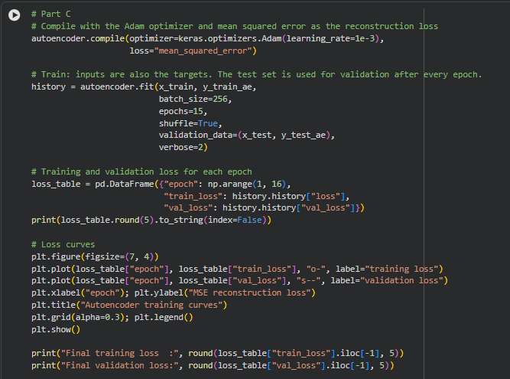

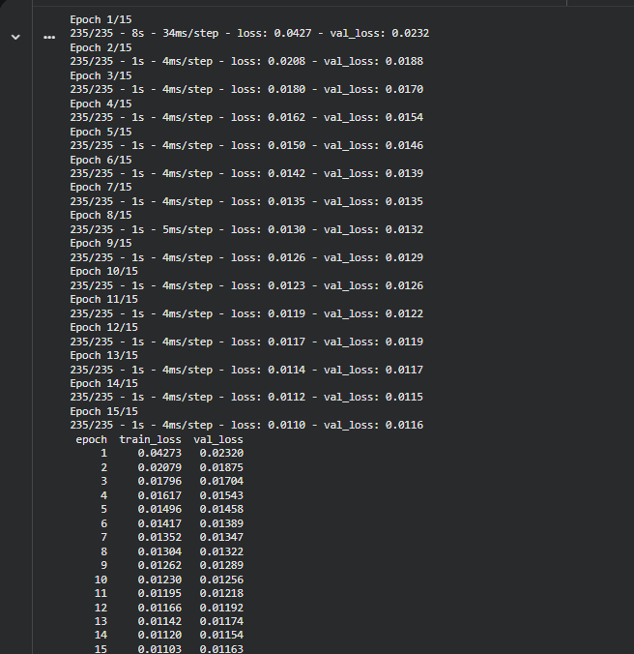
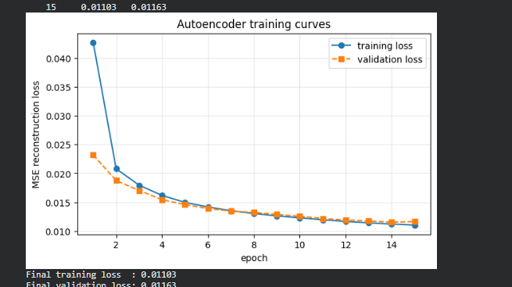

PART D: DIMENSIONALITY REDUCTION, FEATURE LEARNING AND RECONSTRUCTION
Perform the following tasks:
- Use the trained encoder to convert test images into lower-dimensional latent feature vectors.
- Display the original input dimension (784) and latent dimension (for example, 32).
- Pass the latent vectors through the decoder to reconstruct the images.
- Display original images and their corresponding reconstructed images side by side.
- Compare the original and reconstructed images and comment on the information retained or lost.
- Optionally, use PCA or t-SNE to visualize latent features in two dimensions, if covered in the course.
- Save the trained model or reconstructed images if required.

CODE AND OUTPUT :

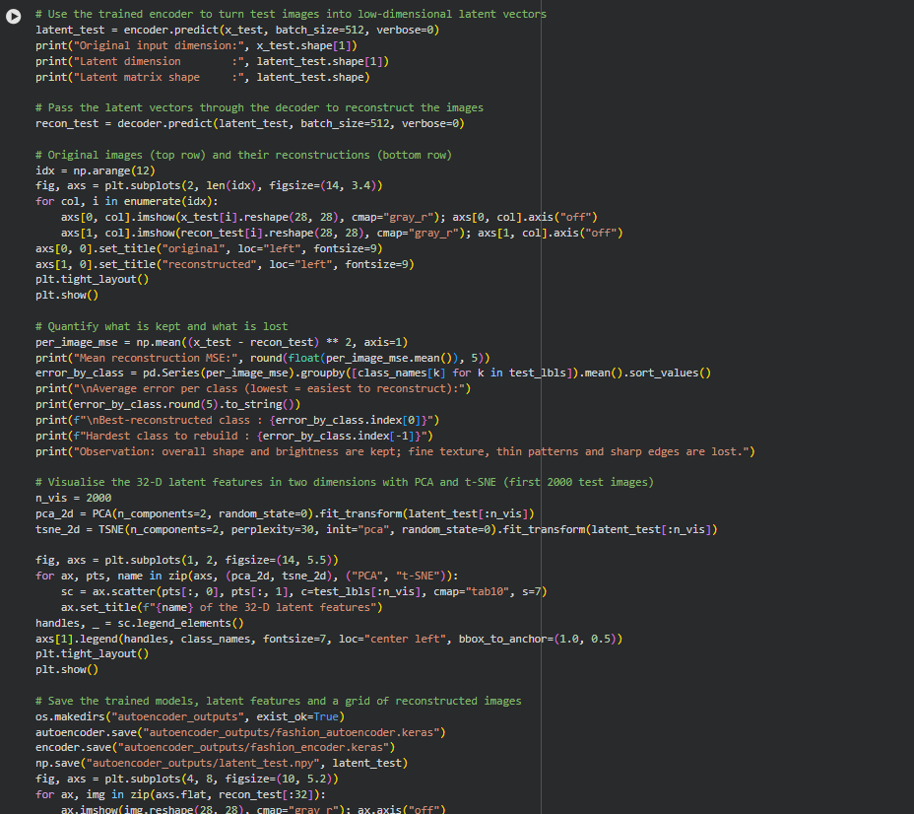

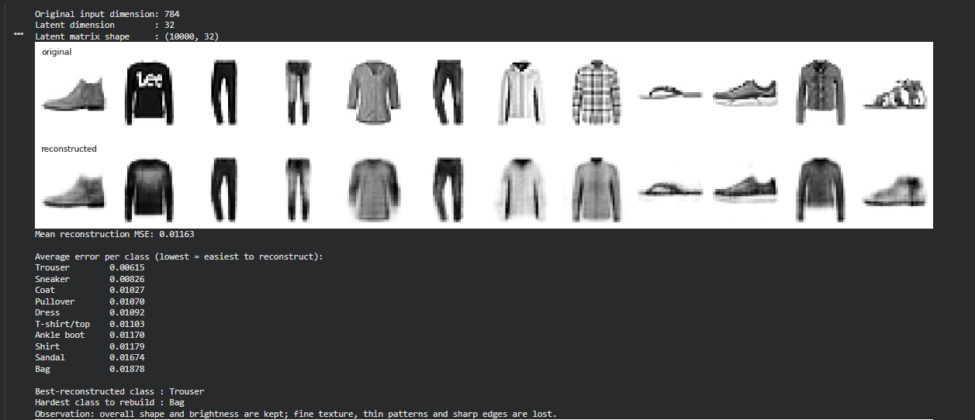

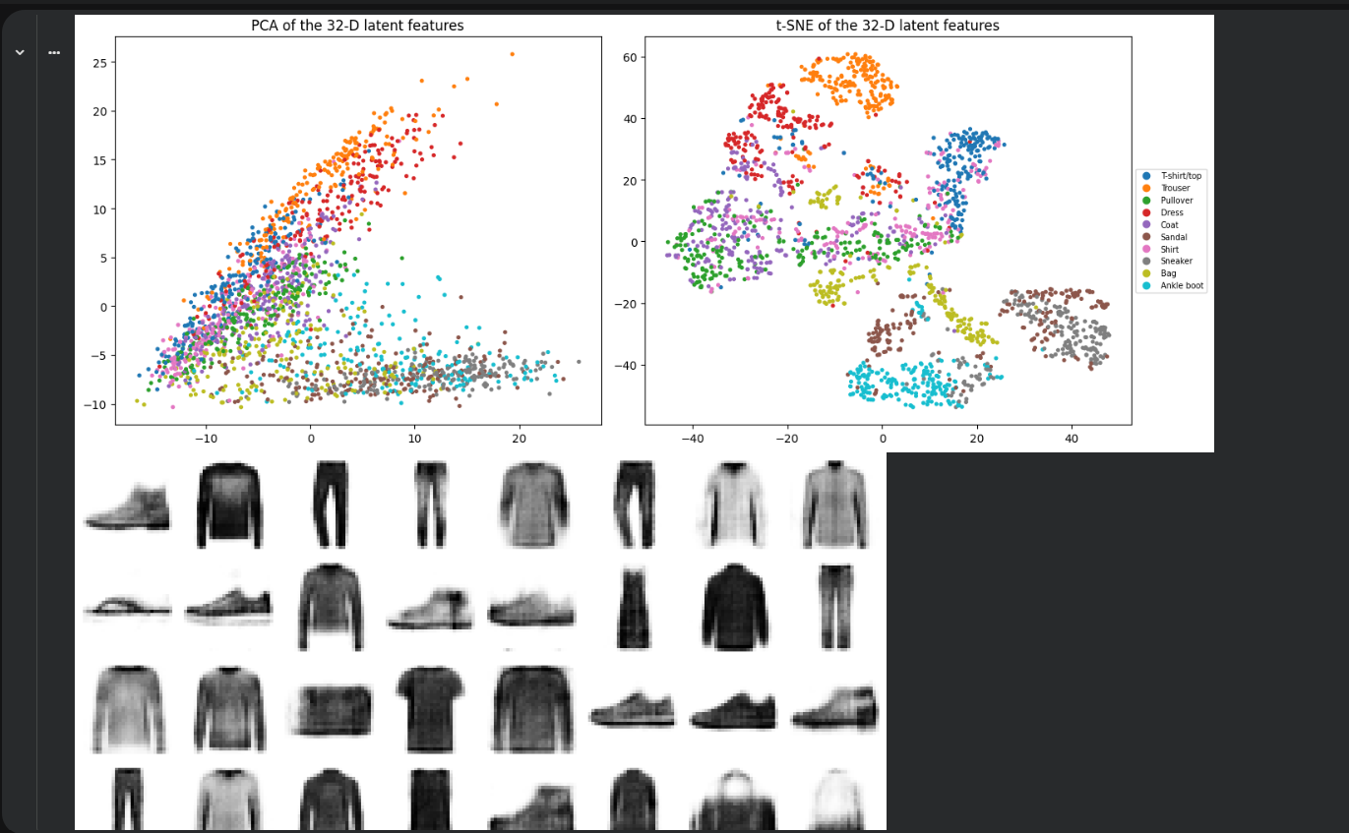

EXPECTED OUTCOME
Students will understand the architecture and working of a simple autoencoder and the roles of its encoder, latent representation, and decoder. They will learn to preprocess data, train the model using reconstruction loss, reduce input dimensionality, and extract compact latent features. They will evaluate the autoencoder by examining training and validation loss and comparing original images with reconstructed images.

POST-LAB QUESTIONS (PROVIDE BRIEF ANSWERS TO THE FOLLOWING QUESTIONS)

- What is the main purpose of an autoencoder?
Ans: To learn a compact, meaningful representation of data by compressing it and reconstructing it. This is used for dimensionality reduction, feature learning, denoising, anomaly detection and data compression.
- How do the encoder and decoder differ?
Ans: The encoder reduces dimensionality (784 → 256 → 128 → 32 in this lab) and produces the latent vector. The decoder expands it back (32 → 128 → 256 → 784) and uses a sigmoid output so pixel values stay in [0, 1]. The decoder is roughly a mirror image of the encoder.
- What is a latent representation?
Ans: It is the low-dimensional vector (32 numbers here) that the encoder outputs for each input. It summarizes the essential features of the image and is what the decoder uses to reconstruct it; it can also be used as input features for other models or for visualization.
- How does an autoencoder perform dimensionality reduction?
Ans: The narrow bottleneck layer has far fewer units than the input, so the network is forced to keep only the most informative features in order to reconstruct the input well. After training, passing data through the encoder alone gives the reduced representation (784 → 32). Unlike PCA, it can learn non-linear relationships.
- Why are the input images also used as target outputs during training?
Ans: Because the goal is reconstruction: the network must reproduce what it receives. Using the input as the target needs no labels (self-supervised learning), and the error between output and input tells the network how well the compressed code preserved the information.
- What does reconstruction loss measure?
Ans: It measures the difference between the original input and the reconstructed output, e.g. the average squared pixel error for MSE. A lower value means the reconstruction is closer to the original and less information was lost.
- What may happen if the latent dimension is too small?
Ans: Too much information is thrown away (underfitting): reconstructions become blurry or lose details, the loss stays high, and different inputs may be mapped to similar codes. If the latent dimension is too large, the autoencoder may simply copy the input and learn nothing useful.
- Mention one real-world application of autoencoders.
Ans: Anomaly (fraud) detection: an autoencoder trained on normal data reconstructs it well but gives a high error for unusual samples. Other uses: image denoising, image compression and feature extraction.

SUGGESTIONS FOR DATASETS
- MNIST Handwritten Digits – https://www.tensorflow.org/datasets/catalog/mnist
- Fashion-MNIST – https://www.tensorflow.org/datasets/catalog/fashion_mnist
- CIFAR-10 – https://www.tensorflow.org/datasets/catalog/cifar10 (requires adapting the model for image inputs)

ASSESSMENT
Description | Max Marks | Marks Awarded
Pre Lab Exercise | 5
In Lab Exercise | 10
Post Lab Exercise | 5
Viva | 10
Total | 30
Faculty Signature

